**Assignment-18**

**Git clone:**

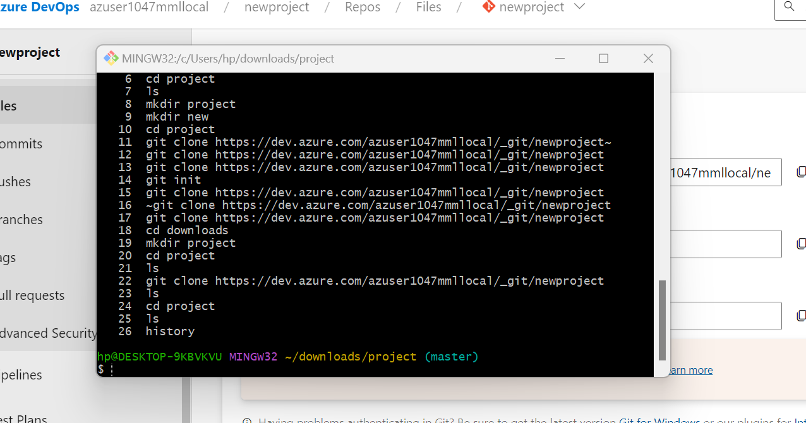

**Git push:**

**Git pull:**